**Chart 1**

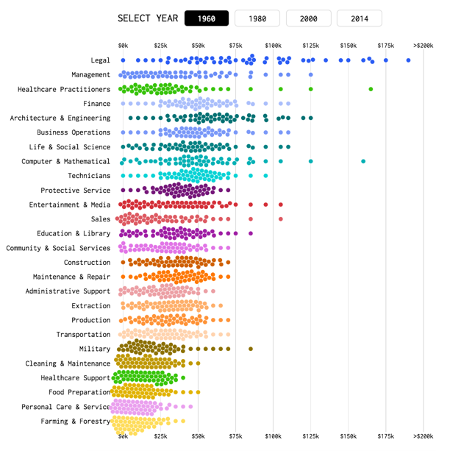

<https://flowingdata.com/2016/06/28/distributions-of-annual-income/>

channels: color encodes occupation group, horizontal position annual income

marks: points

dimensions: 3

* year
* annual income
* occupation groups

**Chart 3**

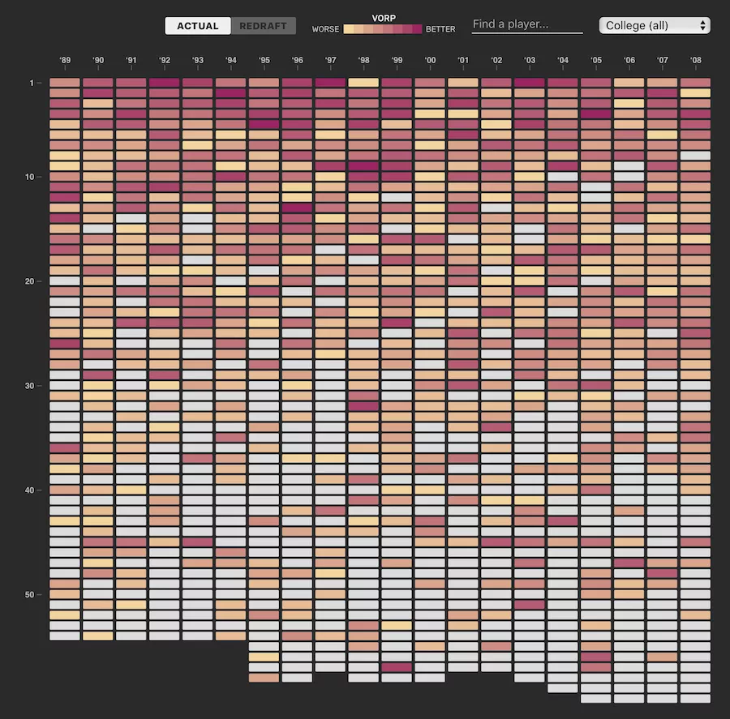

<http://polygraph.cool/redraft/>

channels: color scale, position (vertical and horizontal)

marks: area (rectangles)

dimensions: 5

* years (horizontal axis)
* VORP – value over replacement player (vertical axis)
* status (actual/redraft)
* player name
* college

**Chart 4**

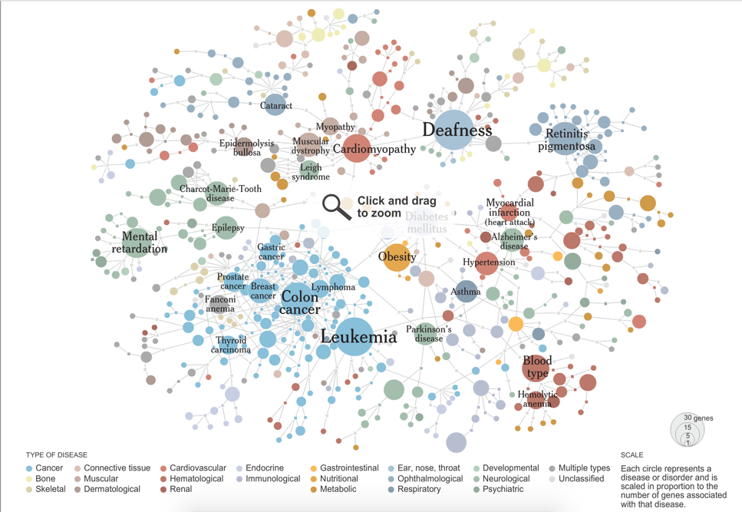<http://www.nytimes.com/interactive/2008/05/05/science/20080506_DISEASE.html>

channels: color, size (area)

marks: point (circle), lines (connections)

dimensions: 3

* type of disease (color)
* size (area)
* number of connections